„ S.A.W.Z.E.“

“The Super Awesome Wheelchair Zombie Escape”

Project Arbeit 1.Semester, Games Academy Berlin

Vision Document

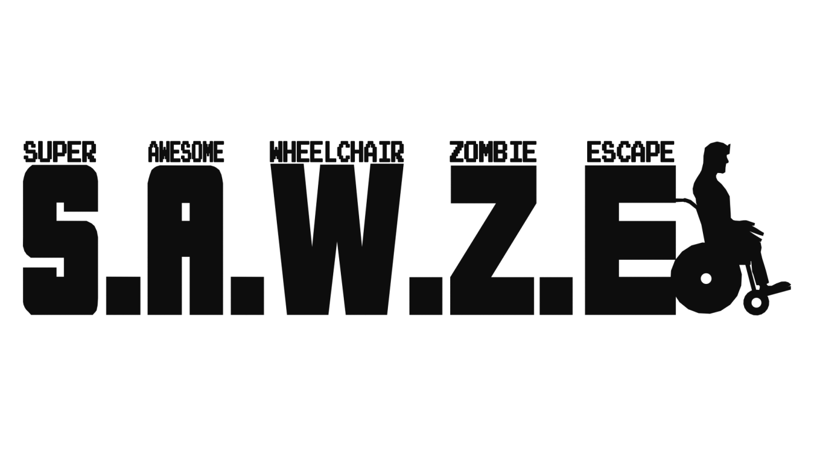

Inhalt

1. Vision Statement 1

2. USPs 2

3. Core Characteristics 3

4. Story and Setting 3

5. Core Features 3

6. Art and Game Reference 4

7. Art Work 5

8. Team 7

# Vision Statement

The game S.A.W.Z.E. is inspired by the old school arcade legend “Pac-man” and it aims to bring out the hectic and dynamic game play into a modern theme with more complex mechanics. The main goal of S.A.W.Z.E. is to add diverse features like collectable power up items or different opponent types, as well as to add level objectives for the player to accomplish, while keeping simple and dynamic gameplay.

Signature game mechanics of pac-man such as the constant motion of the character who can be navigated by the player in all 4 directions, but cannot stop, the collection of point-giving items at each step, as well as the top-down view perspective over the level will be discovered in the mechanics of S.A.W.Z.E., however all of them will have a special and unique twist on them, thus adding to and expanding the classic game feeling and atmosphere without just being a blank copy of it.

# USPs

* **Level Objectives**

It is not enough just to escape from the level in order to be successful in SAWZE. Before the escape, the player needs to accomplish a task and by doing so the level exit is activated. These tasks will be always shortly communicated in the form of a level briefing and will be orientated in the context of supporting and protecting a group of survivors. This way the player will have a feeling of purpose when navigating through the levels, but will not be distracted by cut scenes or story telling elements.

* **Dynamic Gameplay**

The fact that the player cannot stop, but only determine the direction of movement, the Virus clouds draining the health bar, the limited antidotes placed on the level, which recover the health of the player and the constant danger of the zombies lurking around, combined with the limited possibility of eliminating these dangers, provided only by occasional and limited power ups, will provide the payer with a dynamic and hectic game experience and give him/her the sensation of constant necessity to move and escape.

* **Power ups**

Throughout the levels the player will have the chance to collect and use diverse but limited power up items, which will be of significant aid to him in accomplishing his tasks and escaping each level.

* **Art Stile**

SAWZE will bring the player in a well-rounded and smooth cartoony environment, defined by bright and strong colors and simple, clear but organic shapes of assets and characters. Goal is to create a game world with abstract designs, which give the player a feeling of being in a comic book or a cartoon, but remain close to realistic objects and items that are easy to recognize and identify with. Such effect is to be achieved by the choice, balance and contrast of colors, dark outlines and smooth, round, low detail in both environment objects and characters.

* **Fun Gameplay and visual presentation**

The main USP of SAWZE is the combination of the dynamic but intuitive game play and the fun cartoon stile of the game. It is very easy for the player to interact with the game and achieve a feeling of flow already in the first minutes. The level design and art of the game are communicating a goofy fun experience for a wide potential target group of players and even losing the game is not provoking negative feelings and frustration, but is rather a teaser for the player to give it just one more try.

# Core Characteristics

|  |  |
| --- | --- |
| Genre | Arcade - Jump and Run |
| Age | 7+ |
| Player Gender | both |
| Platform | PC |
| Player Gaming Experience | None required |

# Story and Setting

In the middle of a scary zombie virus outbreak a new hero rises. Not the classic fast, strong, charismatic, young action hero, who fights his way through Zombie hordes armed with nothing but his pocket knife and can run through walls, but a rather different hero: Major Tomahawk is a retired, old war veteran in a wheelchair, due to an old injury. He lives alone and usually doesn’t favor the company of other people and neither do other people like being in his company.

Never the less, when helpless people need his aid in this scary zombie chaos, Major Tomahawk takes initiative in his hands and rises to any challenge, regardless the limits set to him by age and the wheelchair, which constantly has issues with the brakes.

Soon he finds himself protecting a group of survivors and volunteering for the most difficult of tasks.

# Core Features

* Level Objectives

Each level will have a special objective for the player to accomplish before being able to unlick the exit and escape the level. Sometimes the player will be challenged to scavenge for supplies like food or medicine and other times the player will have to save trapped survivors and escort them out of the level.

* Constant Contamination and Concentrated Zombie Virus Clouds

With each step the player will lode health in the zombie virus contaminated world of SAWZE. On some places there will be concentrated virus delivering a great health penalty to the player. And the only way to recover health will be collecting the antidotes. So there is no time for hesitation! SAWZE will catapult the player from the first minute of gameplay in a dynamic and intense fast-pace game experience.

* Power Ups

The player has several power ups hidden in the levels. Collecting them will deliver a massive advantage and will have significant impact on the game world. Get a nitro pack and speed up crazy through the level, trigger an alarm, which will attract all zombies to a location and clear the path to the next objective or get the Super Awesome Antidote, giving to the player the ultimate strength in SAWZE – becoming not only invulnerable to the zombie opponents but also the ability to turn them back to humans!

* Different Zombie Opponents

Some zombies might mindlessly follow their patrol path on the level, thus being really dangerous only in great numbers, but others might be able to track and hunt you down, forcing the player to change his chosen route and run for their lives seeking a way to lose the hunter from their backs!

# Art and Game Reference

* Game Reference

-Pacman

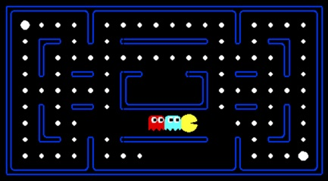

* Art References

-Plants vs Zombies(Comic styled Zombies)

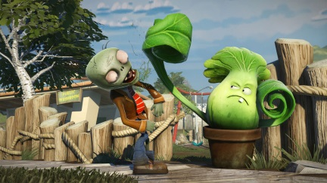

-Prison Architect(Interesting looking Topdown Game)

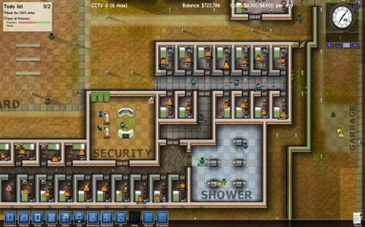

-Comics (like Donald Duck, etc.)

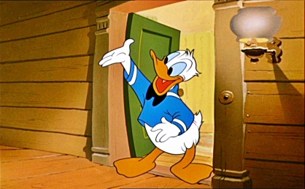

-Worms 3d(General Style and GUI)

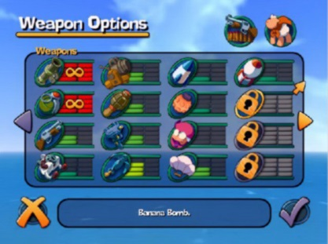

# Art Work

Environment Art:

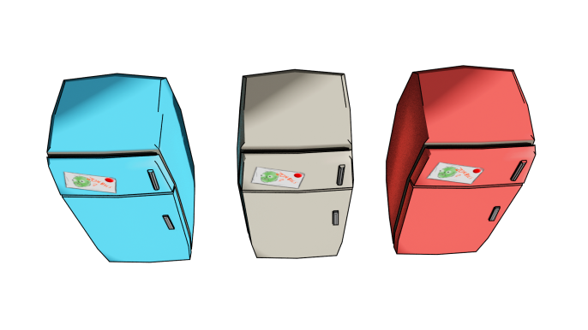

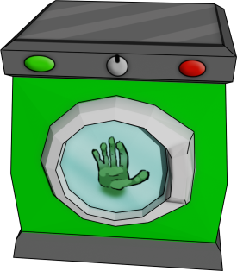

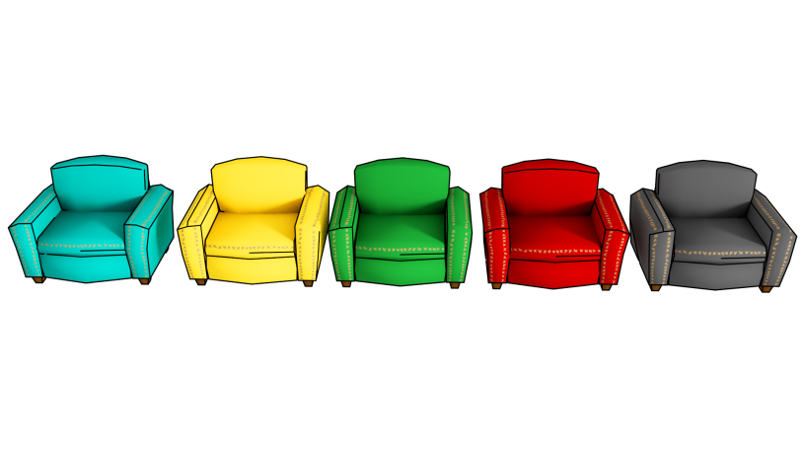

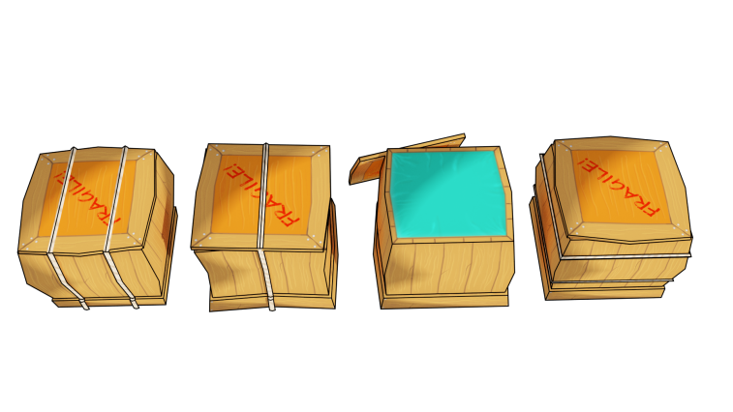

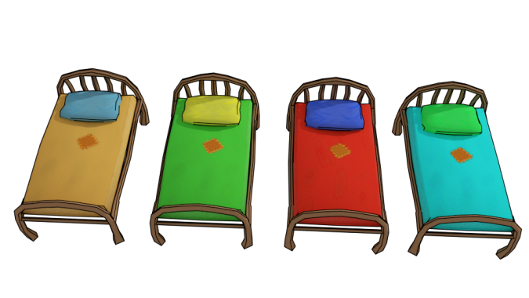

* Characters

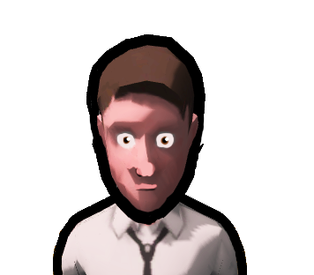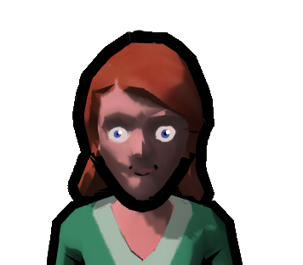

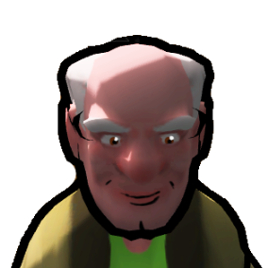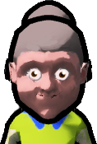

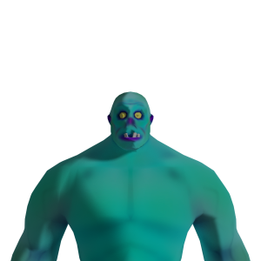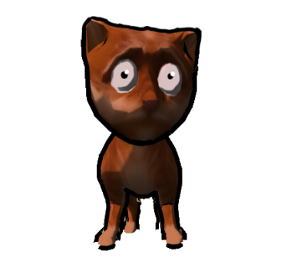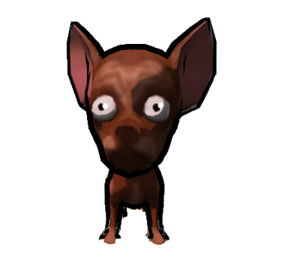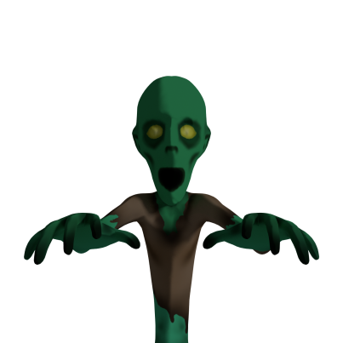

* Unique Level Assets

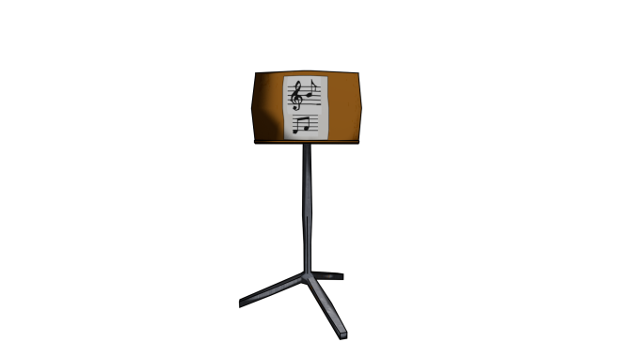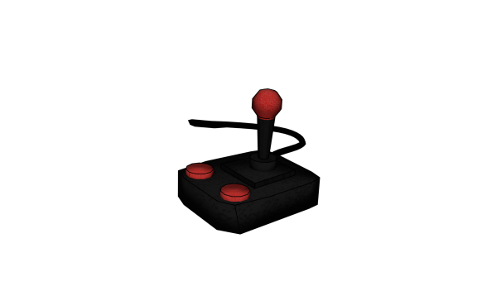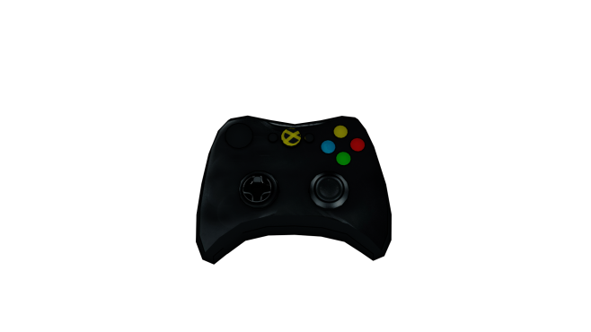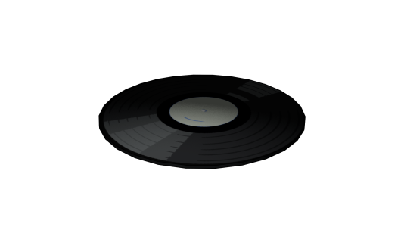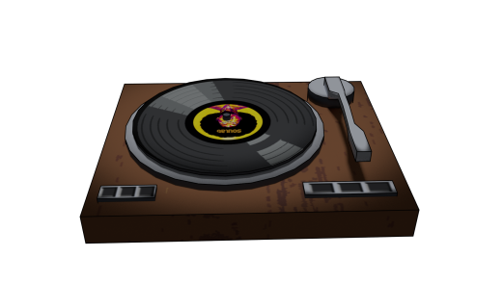

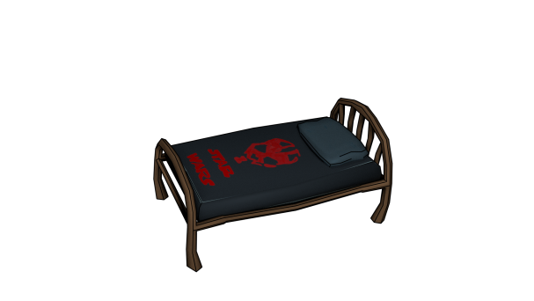

# Team

Tobias Paul – Character Art and Animation

Amon Kalagin – Setting, Environment Art and modelling

Daniel Pochert – Programming

Robert Lücke – Game Design

Andrea Schelling - Setting, Environment Art and modelling

Toma Komitski – Game Design and Production

External member:

[Markus Zierhofer](https://www.facebook.com/markus.zierhofer?fref=nf) - Music and Sound effects